Julian Calendar
# Source: AI Source: Provided by: [Data Path: Persons Table -> ID Column: 1, Name_En Column: Motasem Essam] -> From: [ChatGPT] on [7/17/2026]
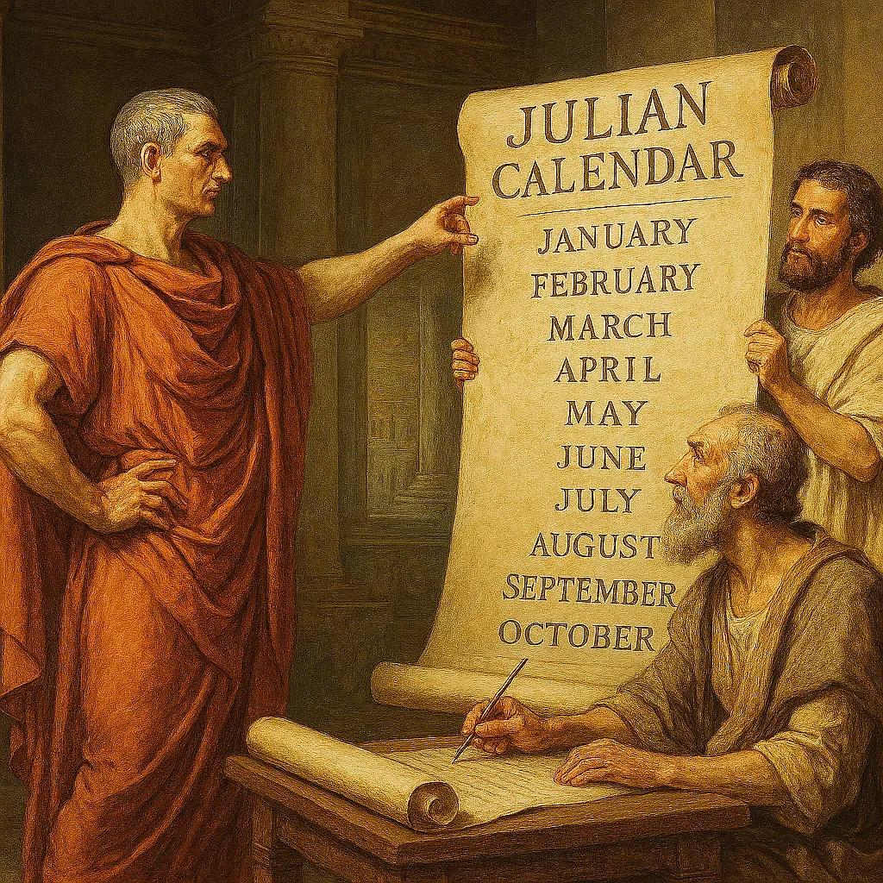
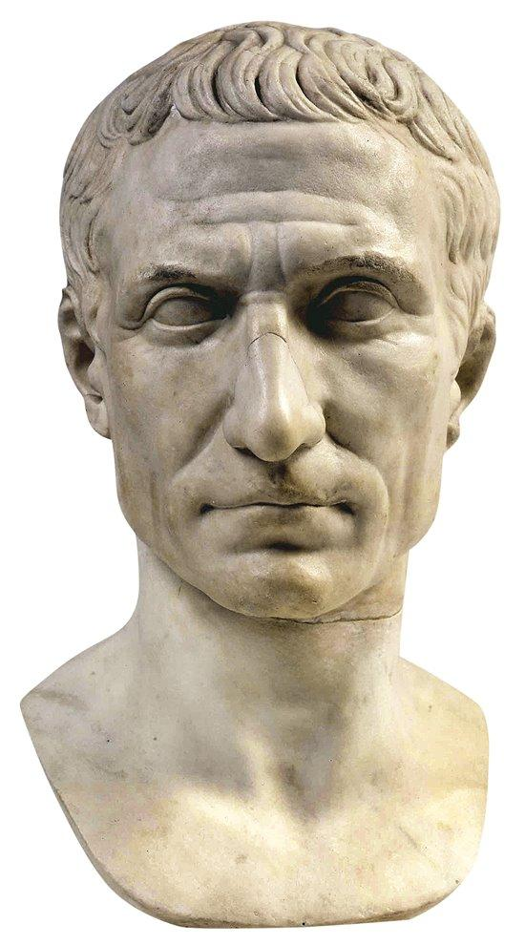
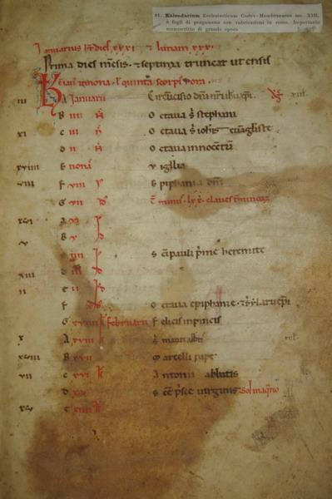
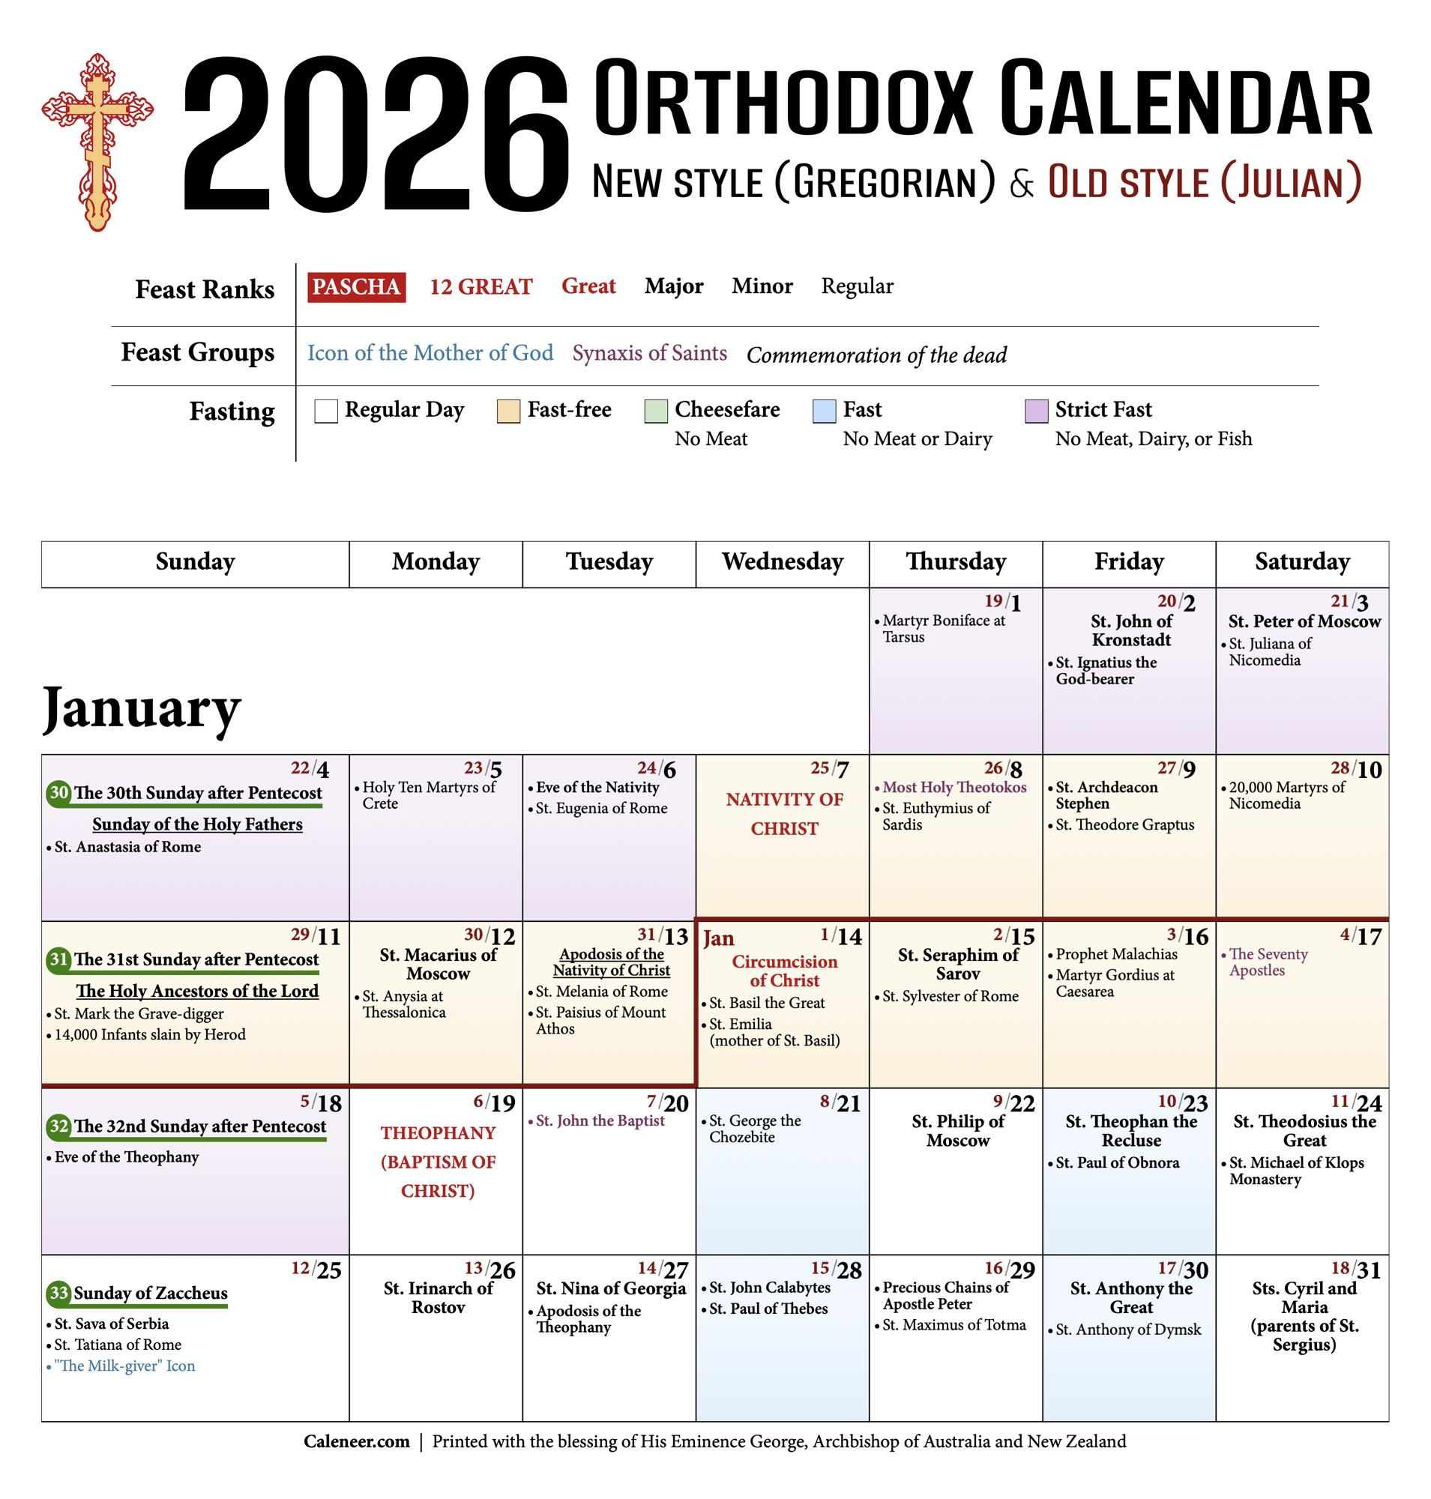
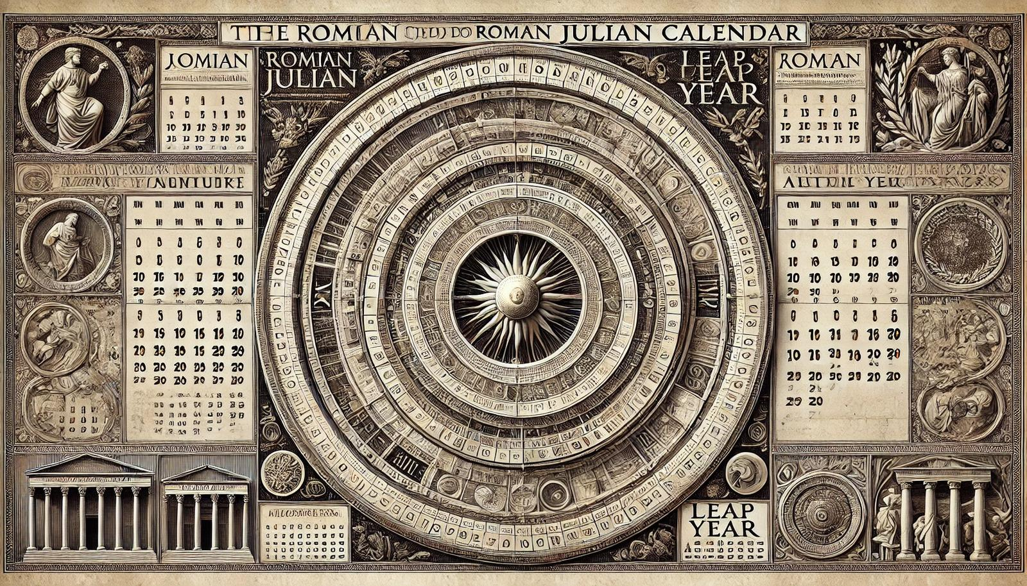
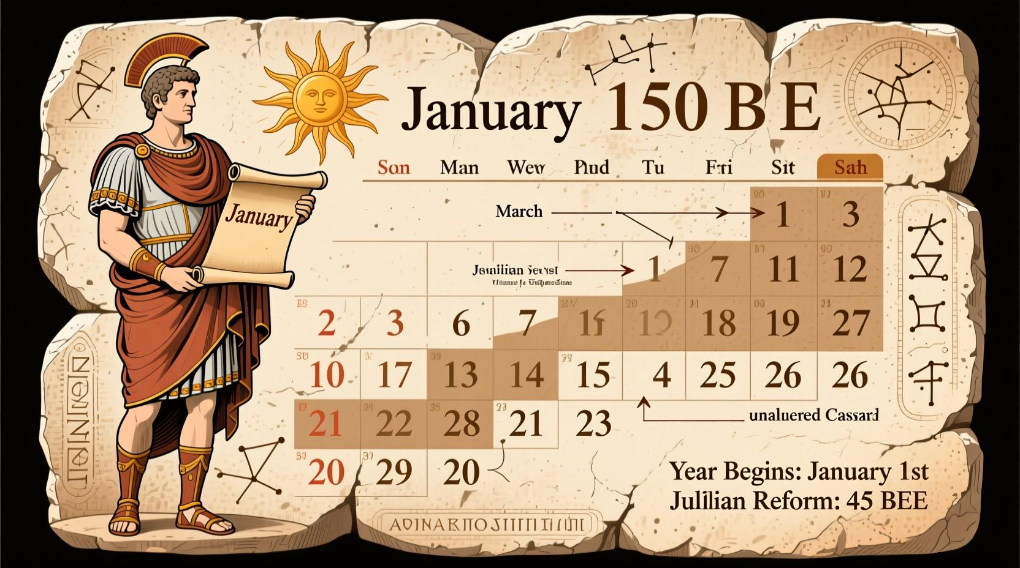
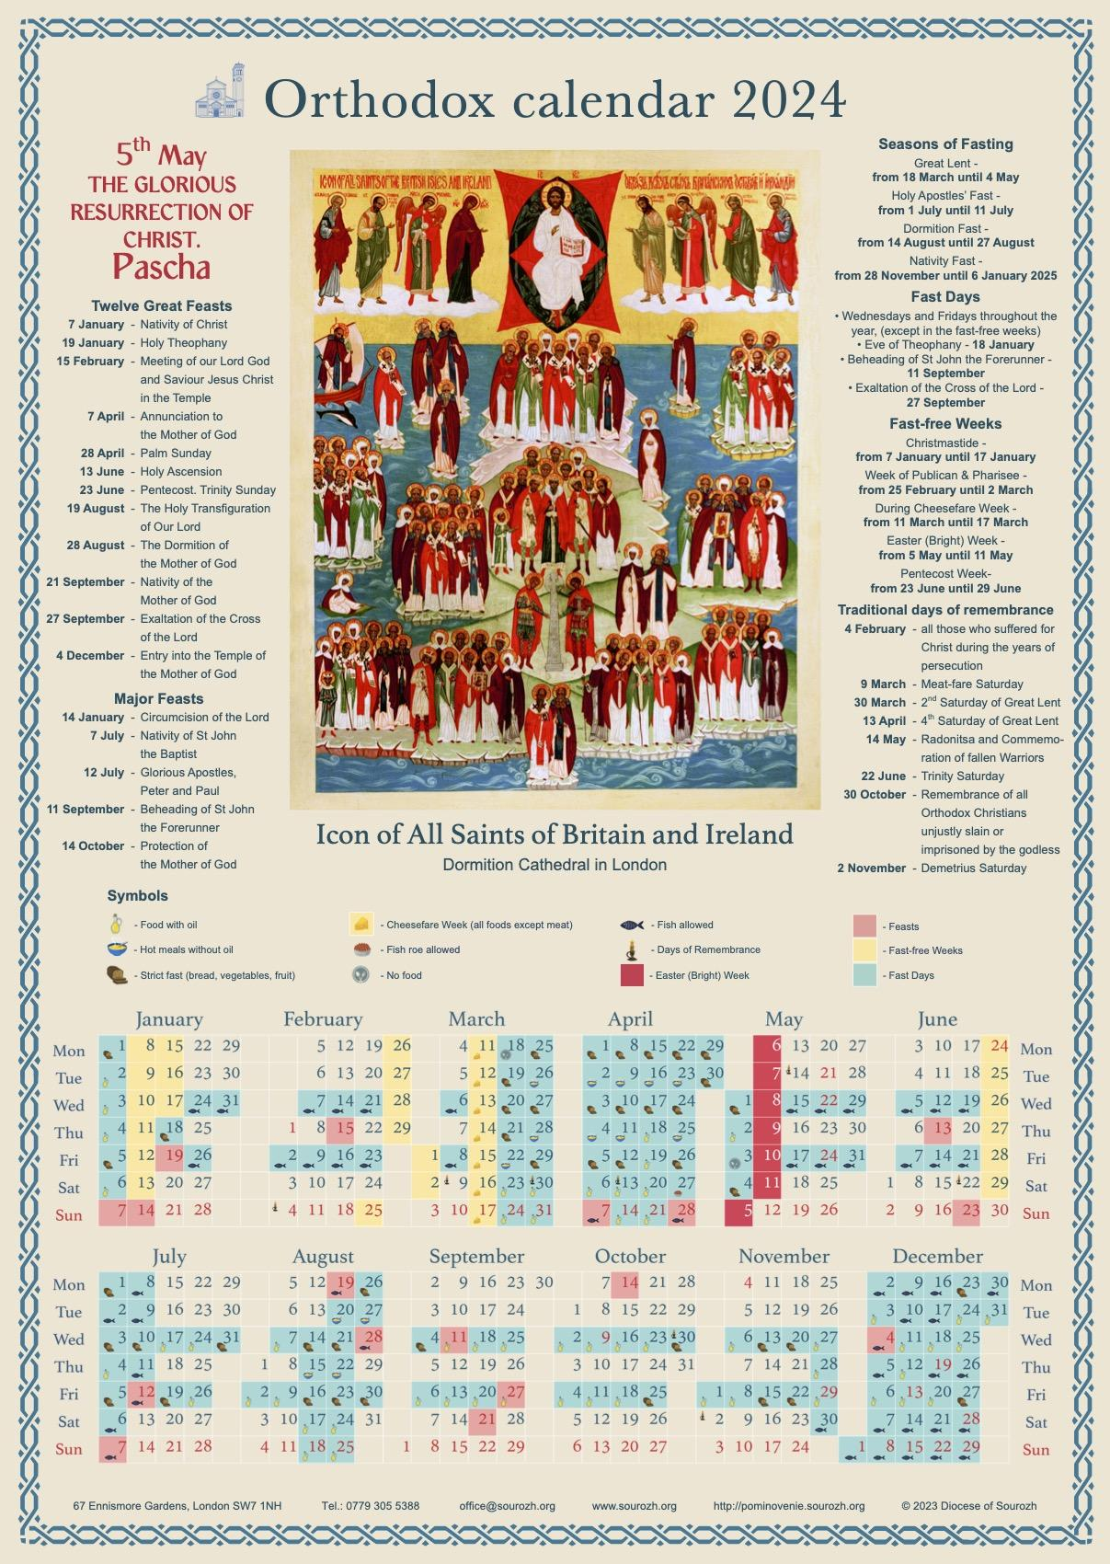
The Julian Calendar is a solar calendar introduced by Julius Caesar in 45 BCE. It replaced the earlier Roman calendar and became the standard calendar throughout the Roman Empire and much of Europe for over 1,600 years.
The Julian Calendar introduced a simple leap-year rule that greatly improved calendar accuracy compared to earlier systems. However, its estimate of the solar year was slightly too long, causing the calendar to drift gradually with respect to the seasons. This led to the later adoption of the Gregorian Calendar in many countries.

Definition
# Source: AI Source: Provided by: [Data Path: Persons Table -> ID Column: 1, Name_En Column: Motasem Essam] -> From: [ChatGPT] on [7/17/2026]
The Julian Calendar is a solar calendar introduced in 45 BCE by Julius Caesar, consisting of 12 months and a leap year every four years, giving an average year length of 365.25 days.

Purpose
# Source: AI Source: Provided by: [Data Path: Persons Table -> ID Column: 1, Name_En Column: Motasem Essam] -> From: [ChatGPT] on [7/17/2026]
The Julian Calendar was created to:
- Replace the inaccurate Roman calendar.
- Standardize the length of the year.
- Keep civil dates more closely aligned with the seasons.
- Simplify timekeeping across the Roman Empire.
- Support administration, agriculture, and taxation.

History
# Source: AI Source: Provided by: [Data Path: Persons Table -> ID Column: 1, Name_En Column: Motasem Essam] -> From: [ChatGPT] on [7/17/2026]
Creator
The calendar reform was ordered by:
- Julius Caesar
It was developed with the assistance of the Alexandrian astronomer:
- Sosigenes of Alexandria
Year Introduced
- 45 BCE

Type of Calendar
# Source: AI Source: Provided by: [Data Path: Persons Table -> ID Column: 1, Name_En Column: Motasem Essam] -> From: [ChatGPT] on [7/17/2026]
The Julian Calendar is a:
- Solar Calendar
It is based on:
- The Earth's revolution around the Sun.

Structure of the Julian Calendar
The Julian Calendar contains:
- 12 months
- 365 days in a common year
- 366 days in a leap year

Months of the Year
# Source: AI Source: Provided by: [Data Path: Persons Table -> ID Column: 1, Name_En Column: Motasem Essam] -> From: [ChatGPT] on [7/17/2026]
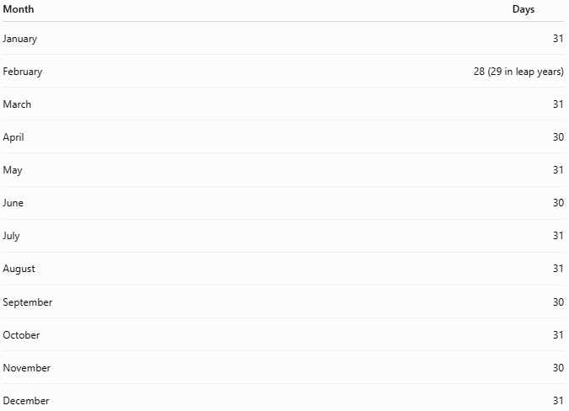
Month | Days
January | 31
February | 28 (29 in leap years)
March | 31
April | 30
May | 31
June | 30
July | 31
August | 31
September | 30
October | 31
November | 30
December | 31

Leap Year Rule
# Source: AI Source: Provided by: [Data Path: Persons Table -> ID Column: 1, Name_En Column: Motasem Essam] -> From: [ChatGPT] on [7/17/2026]
The Julian Calendar uses a simple rule:
A year is a leap year if it is divisible by 4.
Examples:
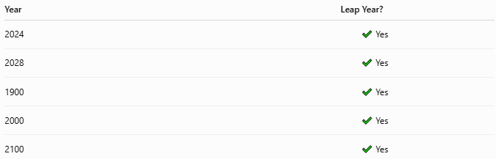
Year | Leap Year?
2024 | ✔ Yes
2028 | ✔ Yes
1900 | ✔ Yes
2000 | ✔ Yes
2100 | ✔ Yes
Unlike the Gregorian Calendar, century years are always leap years if divisible by 4.

Average Length of the Year
# Source: AI Source: Provided by: [Data Path: Persons Table -> ID Column: 1, Name_En Column: Motasem Essam] -> From: [ChatGPT] on [7/17/2026]
The Julian Calendar assumes an average year length of:
$$\boxed{365.25\text{ days}}$$
The actual tropical (solar) year is approximately:
$$365.2422\text{ days}$$
Difference:
$$365.25-365.2422≈0.0078\text{ days per year}$$
This is about 11 minutes and 14 seconds too long each year.

Calendar Drift
# Source: AI Source: Provided by: [Data Path: Persons Table -> ID Column: 1, Name_En Column: Motasem Essam] -> From: [ChatGPT] on [7/17/2026]
Because of this small error, the Julian Calendar gradually drifted away from the seasons.
Approximate drift:
- 1 day every 128 years
By the 16th century, the accumulated difference was about 10 days, which motivated the Gregorian reform.

Weeks
# Source: AI Source: Provided by: [Data Path: Persons Table -> ID Column: 1, Name_En Column: Motasem Essam] -> From: [ChatGPT] on [7/17/2026]
The Julian Calendar uses:
- 7-day weeks
Days of the week are the same as those used in the Gregorian Calendar.

Date Format
# Source: AI Source: Provided by: [Data Path: Persons Table -> ID Column: 1, Name_En Column: Motasem Essam] -> From: [ChatGPT] on [7/17/2026]
Common formats include:

Format | Example
DD/MM/YYYY | 25/04/2026
Month DD, YYYY | April 25, 2026

Applications
# Source: AI Source: Provided by: [Data Path: Persons Table -> ID Column: 1, Name_En Column: Motasem Essam] -> From: [ChatGPT] on [7/17/2026]
Historically, the Julian Calendar was used in:
- The Roman Empire
- Medieval Europe
- Government administration
- Agriculture
- Religious observances
Today it is still used, fully or partially, by some Eastern Orthodox churches for determining certain religious feast days.

Advantages
# Source: AI Source: Provided by: [Data Path: Persons Table -> ID Column: 1, Name_En Column: Motasem Essam] -> From: [ChatGPT] on [7/17/2026]
The Julian Calendar:
- Was much more accurate than earlier Roman calendars.
- Introduced a simple leap-year rule.
- Standardized civil timekeeping.
- Was easy to calculate manually.

Limitations
# Source: AI Source: Provided by: [Data Path: Persons Table -> ID Column: 1, Name_En Column: Motasem Essam] -> From: [ChatGPT] on [7/17/2026]
The Julian Calendar:
- Assumes a year of 365.25 days, which is slightly too long.
- Gradually drifts with respect to the seasons.
- Requires correction over long periods.
- Has largely been replaced by the Gregorian Calendar for civil use.

Comparison with the Gregorian Calendar
# Source: AI Source: Provided by: [Data Path: Persons Table -> ID Column: 1, Name_En Column: Motasem Essam] -> From: [ChatGPT] on [7/17/2026]
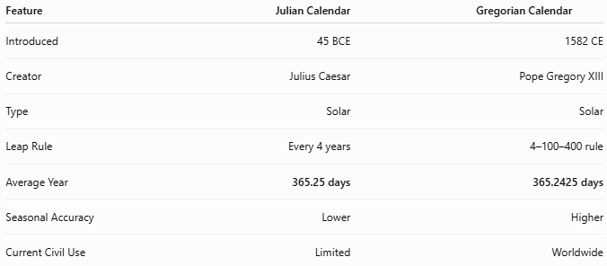
Feature | Julian Calendar | Gregorian Calendar
Introduced | 45 BCE | 1582 CE
Creator | Julius Caesar | Pope Gregory XIII
Type | Solar | Solar
Leap Rule | Every 4 years | 4–100–400 rule
Average Year | 365.25 days | 365.2425 days
Seasonal Accuracy | Lower | Higher
Current Civil Use | Limited | Worldwide

Common Uses Today
# Source: AI Source: Provided by: [Data Path: Persons Table -> ID Column: 1, Name_En Column: Motasem Essam] -> From: [ChatGPT] on [7/17/2026]
The Julian Calendar is still used for:
- Some Eastern Orthodox Christian liturgical calendars.
- Historical studies.
- Chronological research.
- Comparing historical and modern dates.

Common Mistakes
# Source: AI Source: Provided by: [Data Path: Persons Table -> ID Column: 1, Name_En Column: Motasem Essam] -> From: [ChatGPT] on [7/17/2026]
- Assuming the Julian and Gregorian calendars always have the same dates.
- Applying Gregorian leap-year rules to Julian dates.
- Ignoring the accumulated difference when converting historical dates.

Key Points
# Source: AI Source: Provided by: [Data Path: Persons Table -> ID Column: 1, Name_En Column: Motasem Essam] -> From: [ChatGPT] on [7/17/2026]
- The Julian Calendar is a solar calendar introduced in 45 BCE.
- It was created by Julius Caesar with assistance from Sosigenes of Alexandria.
- It contains:
  - 12 months
  - 365 days in a common year
  - 366 days every fourth year
- Its average year is 365.25 days, making it slightly longer than the true solar year.
- The resulting drift of about 1 day every 128 years eventually led to the creation of the Gregorian Calendar.

Conclusion
# Source: AI Source: Provided by: [Data Path: Persons Table -> ID Column: 1, Name_En Column: Motasem Essam] -> From: [ChatGPT] on [7/17/2026]
The Julian Calendar was one of the most influential calendar reforms in history. By introducing a consistent 365-day year with a leap year every four years, it greatly improved timekeeping across the Roman Empire and Europe. Although its estimate of the solar year was slightly too long, leading to a gradual seasonal drift, it remained the dominant civil calendar for over sixteen centuries and continues to be used for religious purposes in some traditions today.

